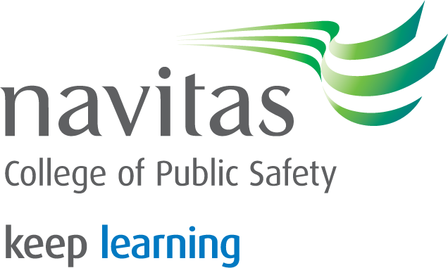

Formal Writing Tips

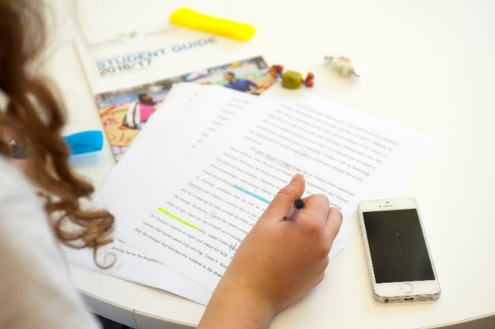

Characteristics of poor Formal Writing:

* ‘Because’, ‘But’, ‘And’, or ‘Or’ at the beginning of a sentence (‘Because’ can be used sometimes, but it is hard to do correctly.)
* Exclamation marks (!) or too many questions (?) – make informed statements rather than emotional descriptions or rhetorical questions.
* Slang – avoid colloquialisms, clichés and text-speak.
* Contractions such as they're, won't, should’ve, it’s etc. – they are too informal (write out both words instead: ‘will not’, ‘should have’, ‘it is’ etc.).
* Vague words such as 'thing', 'stuff', 'and more' etc.
* ‘I’, ‘You’ or ‘We’ (or my/mine, us/our etc.) – keep the writing in third person, formal and objective.

**ACAP Student Learning Support.** ACAP is a college of the Navitas Professional Institute Pty Ltd. National CRICOS Code: 01328A. RTO Code: 0500. **Page 1/1**

Formal Writing

This method of written communication is used in universities, higher education degrees and diplomas, and many publications.

The purpose is to clearly and logically express ideas, research, analysis and conclusions or recommendations.

Formal Writing uses:

**Capitals:** at the beginning of sentences and for names (people, products, places and companies).

**Correct punctuation:** meaning a full stop at the end of all sentences, quote marks around direct quotations, brackets around in-text references and commas where appropriate.

**Consistent tense:** which is usually past tense in assessments. When talking about current theories or experiences, present tense may be used.

**Third person:** so the writing is formal and objective. For example, write about ‘the counsellor’/’counsellors’ instead of ‘I’ or ‘you’; ‘Australia’ or ‘society’ rather than ‘our country’ or ‘our society’.

**Linking words:** such as ‘therefore’, ‘firstly’, ‘secondly’, ‘in addition’ etc. to help the information flow and connect.

**Precise language:** that is clear and accurate, but make sure you don’t use fancy, complex words you don’t understand.

**Correct vocabulary:** where all words are spelt correctly and are appropriate for the context – if you’re unsure of the meaning, look it up.

**Acronyms:** are acceptable when written out in full the first time, then abbreviated in brackets – for example, Navitas College of Public Safety (NCPS).

**Numbers:** are written as words for ten and below, and as digits for 11 and above, except when writing measurements (including money), addresses and dates – for example, 1904 and $2.99.

**References:** are in the correct Harvard format to show where information, ideas, data and quotes have come from. Make sure you check the Harvard Referencing Guide available on the NCPS SLS website.

**ACAP Student Learning Support.** ACAP is a college of the Navitas Professional Institute Pty Ltd. National CRICOS Code: 01328A. RTO Code: 0500. **Page 2/2**